Programme Coordinator

Position description

About Blueprint
Blueprint for Learning (Blueprint) is one of New Zealand’s largest training providers in mental health and addiction, dedicated to both workforce development and community training. We aspire to enhance the wellbeing of people and communities through inspirational learning.
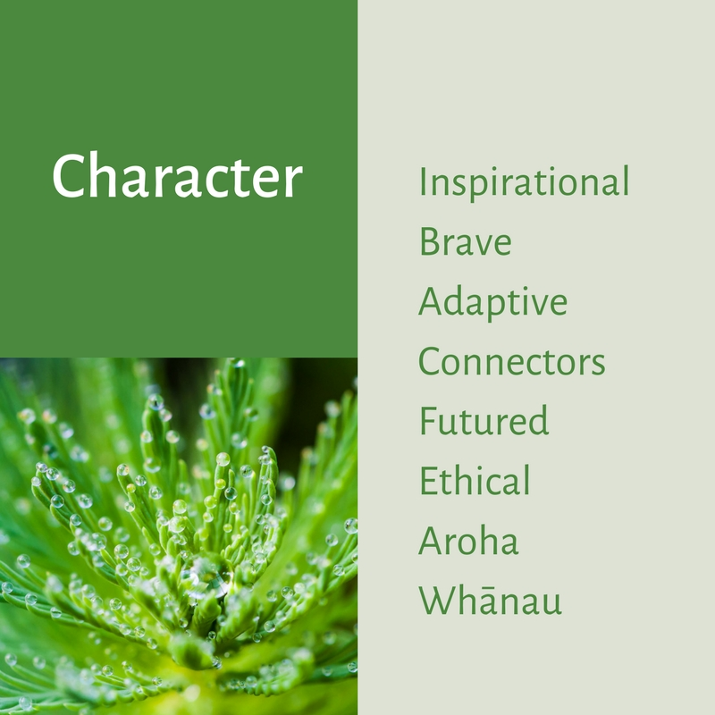
Blueprint is best known for our range of mental health training. We are NZQA registered, demonstrating our commitment to quality, productivity, and customer satisfaction.
Blueprint recognises the importance of whānau, hapū and iwi within Aotearoa. Our goal is to establish high trust collaborative relationships with Māori and to align our services to consider and reflect Māori aspirations and equity within our work.
Blueprint is guided by a Kanorau charter to ensure diversity and inclusion is a core principle of how we work. An example of this is our Rainbow Tick accreditation.
Blueprint is part of the Wise Group, a family of peak performing charitable entities working in areas from frontline service to software development. Blueprint works directly with Te Pou, a national centre of evidence-based workforce development for the mental health, addiction, and disability sectors in New Zealand. They support organisations to implement policy and plan and develop their workforce with practical resources, consultation and education. They use a sound evidence base that builds better services to improve people’s lives.

Purpose
To provide exceptional workshop coordination, planning, reporting and processes to support the commercial learning and development programmes within Blueprint. This will be achieved through coordination of a range of activities to enable successful implementation of the organisation’s mental health and addiction literacy programmes that increases peoples’ confidence to recognise, relate and respond to people who may be experiencing mental health and or addiction issues.
Given this role will primarily support the commercial programmes offered by Blueprint for Learning, working closely with the Commercial Lead, additional tasks will include coordinating stakeholder engagement and contributing to business development activities across all commercial workshops.

Focus
Your role will focus on the following areas.
Efficient coordination of learning and development and workshop requirements
- Independently oversee the registration process through the online workshop management system from initial registration to workshop completion.
- Ensure training is scheduled and facilitated in a seamless manner, including certificate production, administration, development and distribution and returning of workshop resources.
- Manage the scheduling of commercial workshops including arranging dates for workshops, confirming facilitators for the workshops, organising venues and catering of the workshops if required, and arranging resources and equipment for workshops.
- Coordination of online workshops, including technical support of online workshops via Zoom.
- Provide support to the colleagues within the learning and development team
- Maintain liaison between Blueprint and NZQA and ensure compliance requirements are processed
- Proactively contribute to preparation for audits and audit visits.
- Ensure Ministry of Health and commercial customer impact reporting is up to date

Provide efficient operation support across Blueprint
- Locate, organise, enhance and share relevant information and resources to support decision making and effective service delivery to colleagues and contractors within Blueprint & Te Pou.
- Complete tasks in a manner consistent with the values of Blueprint and Te Pou.
- Perform tasks using a variety of tools to provide smooth operational support of Blueprint and Te Pou, including, but not limited to: reception cover, hosting of workshops and meetings, travel coordination, data entry, coordination, management of resources and information management.
- Code and process supplier invoices and/or purchase orders to enable accurate and timely payments for goods and services.
- Induct new administrators on systems and processes for Blueprint programmes and provide ongoing support when required.
- Liaising with approved courier services to ensure required delivery times are met.
- Induct new administrators on systems and processes for Blueprint programmes and provide ongoing support when required.

Provide outstanding customer service
- Provide effective customer service and on-going liaison and exchange of information with people and service providers as appropriate, internally and within the Wise Group.
- Develop and maintain effective relationships with external stakeholders
- Communicate effectively, both verbally and in writing to provide information and support clearly, accurately, and concisely.
- Develop and maintain accurate files, records and information to accepted quality standards in line with Blueprint and Wise Group communication guidelines.
- Proactively contribute to preparation for audits and audit visits.
- General troubleshooting and liaising with staff regarding business systems and processes such as the workshop management system and administration requirements for Blueprint.

Continuously seek new and improved ways of doing things
- Proactively identify system and process improvement opportunities and take appropriate steps to introduce and embed more efficient and effective systems and processes.
- Work collaboratively and cooperatively to maintain and enhance business systems and service delivery practices.
- Individual professional and personal development that supports the values, attitudes and Essential level of the Seven Real Skills of Let’s get real.
- Utilise Te Pou’s Ngā Pou Tāhuhu framework to plan and implement work.

Attributes

You love what we do and enjoy proactively seeking new opportunities to enhance our contribution within the sector and in workplaces. You are excited by the prospect of change, and you keep the bigger picture in mind as you take a lead role within Blueprint for Learning.
You will demonstrate the following attributes:
Inspirational: inspiring others to be their best
Brave: the courage to meet challenges in pursuit of a better world
Adaptive: ability to change to suit different conditions
Connectors: connecting people and ideas for creative outcomes
Futured: Foresightful, forward looking and prescient
Ethical: Ethics before ego
Aroha: Love, caring, compassion and empathy for others
Whānau: Nurturing a family-like culture
Requirements
Essential
- 3 years’ experience working in a similar role, 5 years’ preferred.
- Excellent communication skills, both verbal and written.
- Excellent information technology skills, and intermediate and greater experience using Microsoft Office software suite and other software packages as required.
- Keen attention to detail.
- Highly organised with ability to prioritise and work independently managing multiple demands
- Ability to assess and balance the needs and expectations of diverse stakeholders.
- Participate and collaborate as a member of the team.
- Commitment to personally apply the principles of the Treaty of Waitangi in the work you do.
- Use inclusive and culturally relevant practices in your work.
- Embrace diversity and demonstrate inclusive behaviours.
- Use sound ethical processes with a customer service approach.
- Reflects the Essential level of Let’s get real across the seven Real Skills in work practices.
- Display a passion for working with the sector to improve quality of life outcomes for people using mental health, addiction and disability services.

Preferred
- An understanding of mental health, addiction and disability services.
- Background in stakeholder engagement, with the ability to build and maintain relationships with diverse groups.
- Demonstrated success in coordinating and executing business development activities
- Experience with Customer Relationship Management (CRM) systems, including data management and reporting, to enhance stakeholder engagement and service delivery.

